Abishek Balakrishnan Selvam

Abishek Balakrishnan Selvam | 102009630

Business Report

INF80006 Business Analysis Practice

# *Executive Summary*

*This report is a continuation of the business requirements document submitted to the management of ABC bank which articulates the feasibility of Bank of the Future project. This report details the business requirements gathered from stakeholder analysis through user personas, harm help matrix and degree of influence method. This report lists all the business requirements and three of the most important requirements are taken into consideration. A solution evaluation is performed which includes project release plan, project roadmap, implementation and change management strategy.*

Table of Contents

Executive Summary 1

Introduction 2

Problem Statement 3

Stakeholder analysis 3

User persona 4

Industry Analysis 6

Within Australia 6

Outside of Australia 7

Solution Analysis 8

Industrialised campaign test and learn process 9

Improved campaign development capability 9

Local area marketing portal 9

Customer data mart refinement 10

Cost-Benefit Analysis 10

Business Requirements 12

Release Plan 16

Change Management Plan 19

Define 19

Communicate and engage 19

Prepare Individuals and organisation 20

Embed and culture 20

Conclusion 20

References 22

# Introduction

The low lead actioned and conversion lead at ABC bank assess As-is business process to identify current state of the business process including marketing, customer analysis, channel and technology. After assessment, the main problem for ABC bank is the low conversion rate and lead. There are 850,000 leads with only 35 percent actioned and 3.5 percent conversion in 13 months. It means that employees in bank do not provide customer or potential customer with great personalize the customer experience under a mass of customer information. ABC bank needs a new business process to improve quality of action achieve satisfied conversion rate. There are five main problems of lead action during business process including do not contact with customer, low confidence and awareness, current relationship builder issue, effectiveness problems and proliferation of non-compliant marketing across the network.

# Problem Statement

Through our analysis, there are six interrelated core issues that affects the overall process of lead conversion of ABC Bank.

1. Lack of insights from analytics in driving lead campaigns

Due to reactive dynamic between Marketing and Analytics, campaigns have been driven by incomplete picture of segment profile.

1. Insufficient metrics in evaluating effectiveness of campaigns

No historical data nor financial metrics used to measure effectiveness of previous campaign; thus, no feedback for future campaign planning.

1. Low focus on lead generating campaigns

Current marketing mix only focus on bigger marketing volume, and not on leads only as they only make up 10% of marketing volume.

1. Lack of effective organization-wide communication on marketing activities

Ineffective communication about lead strategy, including governance and compliance, to local branches, causing proliferation of non-compliant marketing.

1. Low confidence and engagement towards leads in the frontline

Frontline staff often do not use the lead to identify sales opportunities and do not receive enough training to use the Relationship Builder.

1. Limited functionality of current marketing tool, Relationship Builder

The Relationship Builder does not have the capability needed to optimally drive future campaign.

# Stakeholder analysis

Stakeholder analysis identifies key internal and external stakeholders of the lead conversion project of ABC Bank. Stakeholders are categorised and prioritised based on importance, influence, level of involvement, frequency of involvement and method of involvement.

|  |  |  |  |
| --- | --- | --- | --- |
|  | **Inform** | **Consult** | **Involve** |
| **High** | Board of Directors | Change Dept  Brand & Advertising | Direct Marketing  Branch Marketing  Data Analytics  IT/Technology |
| **Medium** | Financial Services | Customers | Online & Customer Service Centres  Consumer Segment  Performance Manager |
| **Low** | Commercial & Agriculture |  | SME Segment |

*Figure 1:Stakeholder Map*

The group on the top row represents primary stakeholders who have high influence on the project, thus, highly prioritised. Communication to this group is frequent and regular and conducted formally and informally. They are high-power prominent individuals who are decision maker in the project or the department and can provide decision on resources needed for the project, such as funding and human resources. Their decision highly impacts the project.

The second row of the Stakeholder Map includes individuals who are moderately informed, consulted and involved. They include individuals with high interests in the project and need to be involved in certain activities, such as interviews and training of staff.

The last row of the Stakeholder Map includes individuals who are rarely informed, consulted, and involved. They will be informed at the start and on the outcome of the project and will be involved only if requested by key stakeholders.

## Problem Analysis Using User Persona

Based on the Stakeholder Map above, we designed three personas of three individuals who are highly involved or affected in the lead conversion process. A persona is a character created based on research to represent different personalities and segments of individuals (Baden 2009, p. 135). By using personas, we would like to get their perspective to define our problems and requirements.

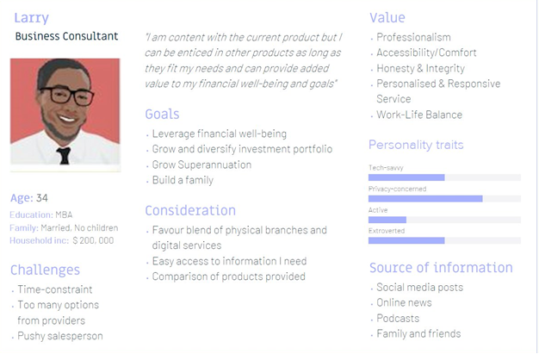

*Figure 2: Buyer Persona of Current Customer & Former Lead*

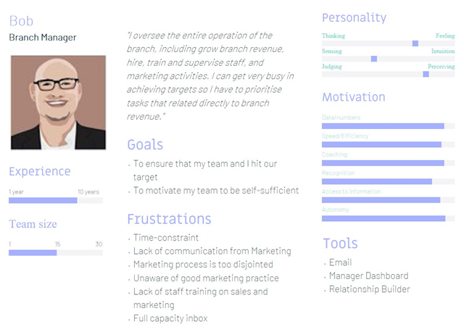

*Figure 3: User Persona of Branch Manager*

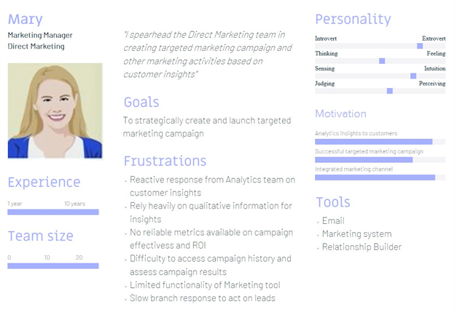

*Figure 4: User Persona of Marketing Manager, Direct Marketing*

# Industry Analysis

## Within Australia

As of recent years, the Australian banking industry is increasingly competitive especially with the rise in popularity of digital banking and the introduction of ‘neobanks’ (Yeates, 2019). In order to keep up with the changing environment of the industry, ABC Bank must adapt to stay competitive especially since digital banking is increasingly appealing to younger markets (Groenfeldt, 2018). Accenture (2019) states that ‘neobanks’ like Gobbill and AirWallex are gradually winning customers over, with increasing market share and adoption, which has result in Australian banks shifting in focus towards upgrading of core digital services to introduce their respective digital banks like Reinventure by Westpac and NAB Ventures by NAB. Banks across Australia are moving towards customer-centric sales practices, involving customer experience improvement strategies and offering of a more personalised and engaging service offering. As such, there Australian banks like NAB and CBA are experimenting with new technical architectures and systems, which are digital, and cloud based. This allows for quality data and lead conversions through understanding of algorithms, which in turn allows customers to be more engaging with the bank, which allows them to provide customers with greater personalisation and creativity in service and product offering (Accenture, 2019).

## Outside of Australia

In the case of DBS Bank in Singapore, there is greater focus on customer experience, shifting marketing strategy from focusing on sales to providing advice and customer communication. With that, they are incorporating banking services which are inclined towards human centred design, emphasising on customer journey thinking, thereby offering banking services which are more personalised and engaging (Groenfeldt, 2018). With the growing significance of digitalisation of Australian banks, which is still in its early stages, ABC Bank has tremendous potential, especially if they learn from the successful strategies as demonstrated by other banks in the industry within and outside of Australia. DBS Bank has been transforming its business model and banking services across South East Asia to appeal more to younger audience, redefining banking in the digital age (Grant, 2018). Taking inspiration from Amazon, DBS Bank implemented AI to design and develop products and services which aligns with their clientele through lead generation obtained through incorporation of digital and social media channels as part of their marketing strategy (Grant, 2018). In engaging with their audience, they were able to establish brand salience, generating and converting leads into profits. Please refer to Figures 5, 6 and 7 below for the current strategies od DBS Bank.

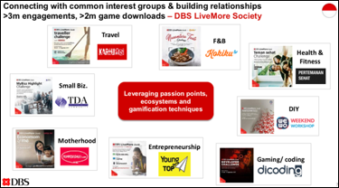

Figure 5: DBS Bank’s customer engagement plan.

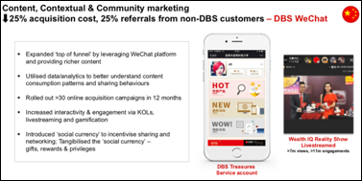

Figure 6: Digital marketing strategy of DBS Bank.

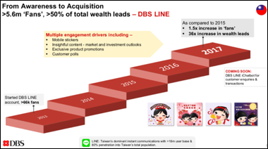

Figure 7: Lead conversion strategy of DBS Bank.

# Solution Analysis

## Industrialised campaign test and learn process

* **Training and development of bankers**

ABC Bank could implement organisation wide training and development programs which are ongoing, to train contact agents on ways in which they could improve upon providing of premium service delivery. These trainings should be optimised by aligning business technology with interpersonal skills of bankers to provide more personalised banking services to customers (Bollard et al., 2014).

## Improved campaign development capability

* **Presence on GAFA Platforms**

ABC Bank could obtain and develop growth opportunities by promoting their product offering on third party platforms like Google, Apple, Facebook and Amazon (GAFA). This allows ABC Bank to connect with prospective customers, engaging and capturing their attention to access ABC’s services at real-time through algorithms like risk scoring and physical space (Gera et al., 2018).

* **Immediate & constant follow-up**

In many cases, huge amounts of leads end up being unconverted as a result of poor follow-up from the business organisation (Sullivan et al., 2019). This problem aligns with that of ABC Bank, in which their contact centre and department agents lack in proactiveness to lead generation and management. As such, there is a need for process improvement and differentiation from competitor banks in the industry. One way around this issue is to constantly strive for superior customer satisfaction, in order to incentivise customers to shift to ABC’s direction.

## Local area marketing portal

* **Accurate Consumer Engagement Channels**

It is recommended that ABC Bank conduct holistic research which would allow them to tap into digital platforms to deliver lead generation, which is unparalleled from competitors, allowing them to leverage sales conversions.

* **Personalised end-to-end consumer journey**

Consolidation of marketing strategies and channels would allow ABC Bank in development of customised and personalised end-to-end customer journeys through channels like social media platforms, online presence and mobile applications, in a way that is iterative and synchronised (Bollard et al., 2014).

## Customer data mart refinement

* **Improving the quality of existing & collected data**

The key to quality improvement of internal data and better leveraging of external data is by integrating together departments throughout the organisation to enable free flow of communication and information (Sullivan et al., 2019). Therefore, ABC Bank should monitor collected data for changes, in order to ensure quality through data wrangling techniques, to design solutions which aligns with the business operational goals.

* **AI enabled personalisation**

ABC Bank could adopt AI powered conversational user interfaces that incorporates SEO configurations which uses machine learning capabilities to help utilise data sources such as location and cookies to tap into customer behaviour and interest, aligning them with ABC Bank’s product and service offerings and connecting customers to the bank through algorithm advertisements allowing them to upsell and cross-sell products and services to the clients (Terrizzano et al., 2016).

# Cost-Benefit Analysis

Based on the problems identified in previous section, cost benefit analysis is conducted to guide management decision making based on the cost, resources and risk involved. Cost benefit analysis is a process that weighs the sum of the benefits of an action against the associated cost of that action.

For the purpose of this report, we focus on intangible benefits and costs or effects from the lead conversion improvement project, such as employee morale, brand equity, customer satisfaction and loyalty, in conducting our analysis.

|  |  |
| --- | --- |
| **Cost** | **Benefits** |
| Financial cost incurred for implementation of campaign tool and training of staff.         Implementation Costs:   * Development of campaign tool/platform * Integration with other systems          Ongoing Costs   * Enhancement and upgrades * Staff training on new process and tools/platforms * New staff training | *Marketing Benefits*     * Ability to create more personalized offer and lead campaigns * Better analytics for more targeted campaigns * Availability of metrics in assessing effectiveness * Better communication method now that branch employees are more informed and effective in actioning and converting leads with more training on marketing activities * Availability of historical campaign data for future campaign planning and reuse |
| *Organisational Benefits*     * Higher spend per customer with improved service levels enabling staff to walk with customers to cross-sell and upsell them on other services and products * Higher spend per customer means increased revenue as more leads are converted and buy more products * Costs saving in the long run as staff can be more effective in converting leads * Employee’s morale improves as they are able to conduct their duties and convert leads more effectively |
| *Customer / Lead Benefits*     * Higher loyalty of customer as more targeted products and services offered * Customer feels their time is valued as the products/services offered are personalized to their needs. |

# 

# Business Requirements

This segment reflects on the business requirements building on the relevant business capabilities determined for the ABC bank.

|  |  |  |
| --- | --- | --- |
| **Business Capabilities** | **Business Requirements** | **Value Derived** |
| C1. Analytics & modelling  Description: Ability toDerive hyper relevancethrough advance analytics to understand consumer buying behaviour and decisions (Kobler et al. 2015). | BR1.1. Deliver real-time proactive analytics to associated departments, specifically the customer-facing teams, to ensure data-driven campaign development.  BR1.2. Improve effectiveness of time spent on analytics to ensure that quality insights are delivered to drive lead quality and better campaign performance.  BR.1.3. Integrating AI and machine learning within the current analytics tool to avoid erroneous/ redundant information, hence ensuring data efficiency and value. | Greater understanding of consumers buying behavior and preferences to provide customized offers to customers hence increasing leads and sales conversion (Accenture 2003).  Ability to choose relevant engagement channels and strategy based on derived customer insights (Kobler et al. 2015). |
| C2. Leads Management  Description: Ability to manage, route, convert and report leads efficiently to drive extensive sales growth (Brown & Gottlieb 2016). | BR2.1. Establish and mechanize a vigorous and speedy-cycle time test and learn process to increase lead quality.  BR2.2. Promote enterprise engagement towards leads through increased collaboration involving pertinent stakeholders such as analytics, campaign management and marketing department.  BR2.3. Implementation of an organization-wide real-time leads ecosystem intended towards leads capturing, tracking, scoring and nurturing, through next best offers through online banking, ATM‟s, etc.  BR2.4. Generate leads through multi-channel leads management and engagement enabling ABC bank to deliver organic leads to respective bank branches.  BR2.5. Alignment and prioritization of leads delivered, pertinent to branch’s strategy and individual capacity.  BR2.6. Improving the leads awareness and confidence amongst the frontline staff to leverage provided leads to increase the leads conversion and value.  BR.2.7. Upgrade the current leads management inbox to ensure that high value-added leads are delivered to respective branches.  BR.2.8. Enhancing the local area marketing portal in integration with the SEO to manage marketing order, execution and to obtain high-value leads. | Move from limited leads management to intelligent leads management. Whereby, valuable information on leads is obtained to acquire higher customer share.  Predictive and cognitive decision making enabled through real time insights gathered on the leads to produce relevant offers. |
| C3. Campaign Management  Description: Ability to execute single-phase and multi/ omni-channel campaigns ensuring customers are presented with a consistent message across all customer touchpoints (Doyle 2005, p. 179). | BR3.1. Provision of a campaign library, enabling Bank Manager to select required campaigns for review and reusability, eliminating duplication of year on year campaign creation activity.  BR3.2. Enablement of a campaign management metrics evaluating the efforts and efficiency of the campaigns implemented.  BR3.3. Conduct iterative modification of campaigns to ensure that non-effective and redundant campaigns are removed to produce efficient campaigns.  BR.3.4. Design and implement campaigns in close collaboration with analytics and leads departments to derive efficiency.  BR.3.5. Provision and improvement of knowledge sharing practices, ensuring the all involved stakeholders are aligned on campaign management components.  BR.3.6. Provision of a platform which enables the comparison of varying vendor applications. | Data-driven campaigns executed to attain optimised revenue through efficient marketing campaigns.  Attainment of organic leads through efficient marketing campaigns, assisting ABC banks to acquire/ retain customers.  Greater stakeholder involvement and interaction through knowledge sharing, enabling ABC bank/ branches to make well-informed decisions. |
| C4. Information Management  Description: Ability to provide and manage data available to users at varying levels within the organisations, ensuring such data is of value, easily accessible and adaptive to dynamically altering environment (Mithas et al. 2011, p. 238). | BR4.1. Enhancement of the current customer data mart enabling the enrichment and derivation of data available and obtained.  BR4.2. Provision of improved governance and compliance policies pertinent to customer data management.  BR4.3. Ensure data is consistent and aligned with the current business structure, processes and strategy, to persistently pursue data creation for future campaigns.  BR4.4. Provision of a centralised data management platform, enabling a shared vision across all the departments. | Efficient data sourcing, storage, analysis and governance will enable ABC bank to have a customer-oriented outlook of essential customer data.  Quality data will enable ABC bank to make well-informed decisions, enhancing their growth and customer share against the competitors. |
| C5. Talent Management  Description: Ability to recruit, manage and sustain value added employees for the organisation. This involves on-going training, learning and development pursued to improve employee's performance and deliver efficiency organisation (Downs et al. 2013, p. 269). | BR5.1. Provision of training & development to build required skills to efficiently obtain and utilise leads.  BR.5.2 Continuous assessment of employees' skills and expertise to use and manage the campaign portal, along with ensuring such change is aligned with the business processes and strategy. | Increase human resource efficiency with regards to the tasks performed, whereby employees are confident to pull leads and convert them efficiently to sales (Bollard et al. 2014). |

# 

# Release Plan

The recommendation that were described in the above section require high involvement of stakeholder so as to successful and should be resilient to changes in strategy during and after implementation so Agile Methodology was chosen which as it’s adaptable to change, involves users during all stages and also helps us realise the value quick when compare to traditional methodologies where the results or the value realisation doesn’t occur until the whole project is complete. Implementation upon successful completion of the sprint is planned to be done using pilot technique where we would implement the project in a small area and test the outcome of the project before implementing it across all branches (Weston 2016).

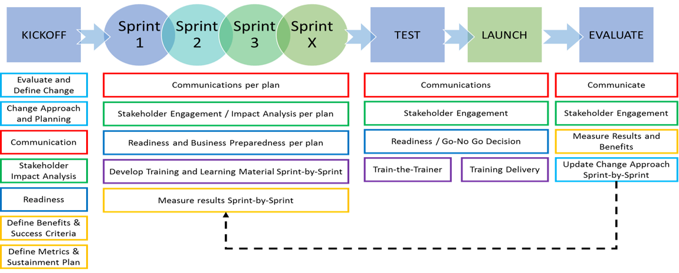

Figure. 8 Agile Methodology (Weston 2016)

The three recommendation (Sub-Projects) are planned to be initiated in the first Quarter of 2020 and would end by the Jan 2021 based on the analysis that was performed it was found that the ABC Bank currently achieves only 3.5% conversion rate and 35% action rate which based on industry average is quite low.

All the Sub-Projects follow the same pattern of implementation and the basic overview would be to kick-off the project followed by several sprints where a test phase occurs in-between the sprints which upon being successful the strategy / product is implemented in local area and based on the suggestions from the stakeholders the strategy will be re-evaluated our strategy against KPIs and redo the whole process again either to improve / fix the issues (Weston 2016).

For implementing Campaign Management, based on the suggestions from project estimation experts, it was estimated to run for about three months and initially two sprints would run for about 15 days followed by a testing which leads to implementation and evaluation and based on the results we would run a couple more sprints but this time it would be for 10 days to improve strategy and fix issues. The estimation of growth after the final release would be a gain of 1% for conversion rate and 5% for action rate. This phase is designed in a way to produce high value in a shorter duration.

As show in the figure 9., the sprint time along with testing, implementation and evaluation goes down after each evaluation phase.

For implementing leads management, it was estimated to run for about seven month and initially there are three long sprints that would run for about 20 days and similar to the implementation of Campaign Management the duration of sprints goes down after each implementation phase that’s because we wouldn’t have to start or perform the changes from start which is one of the advantages of Agile Methodology. The estimation of growth after the final release would be a gain of 1% for conversion rate and 10% for action rate.

Estimation for implementing advanced analytics would be our longest project with the most value and would take about a year to implement final revision of the project and just like the previous implementations we would perform several releases which would again be revised to improve the quality and once we launch the final revision we would gain a 20% increase in the action rate and 2% increase in the conversion rate.

By the end of Q1 2021, the project would have realised it full value that is a gain of 4% overall growth in conversion rate and 35% overall growth in action rate.

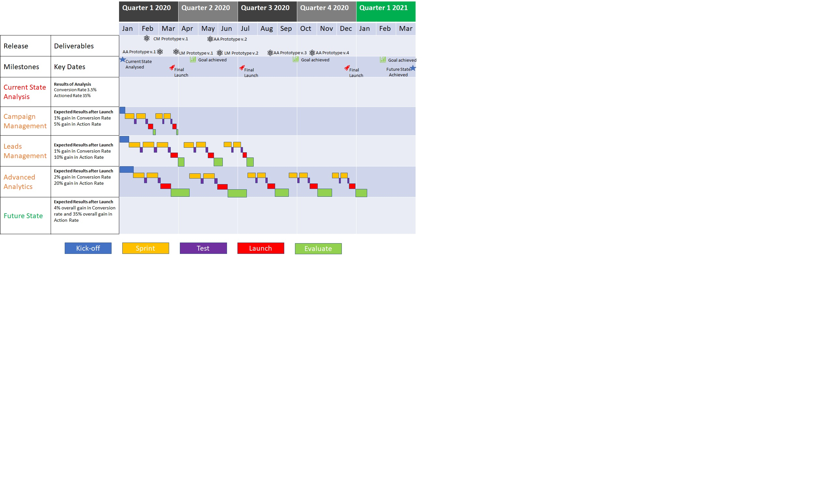

Figure. 9 Implementation Plan / Road Map

# Change Management Plan

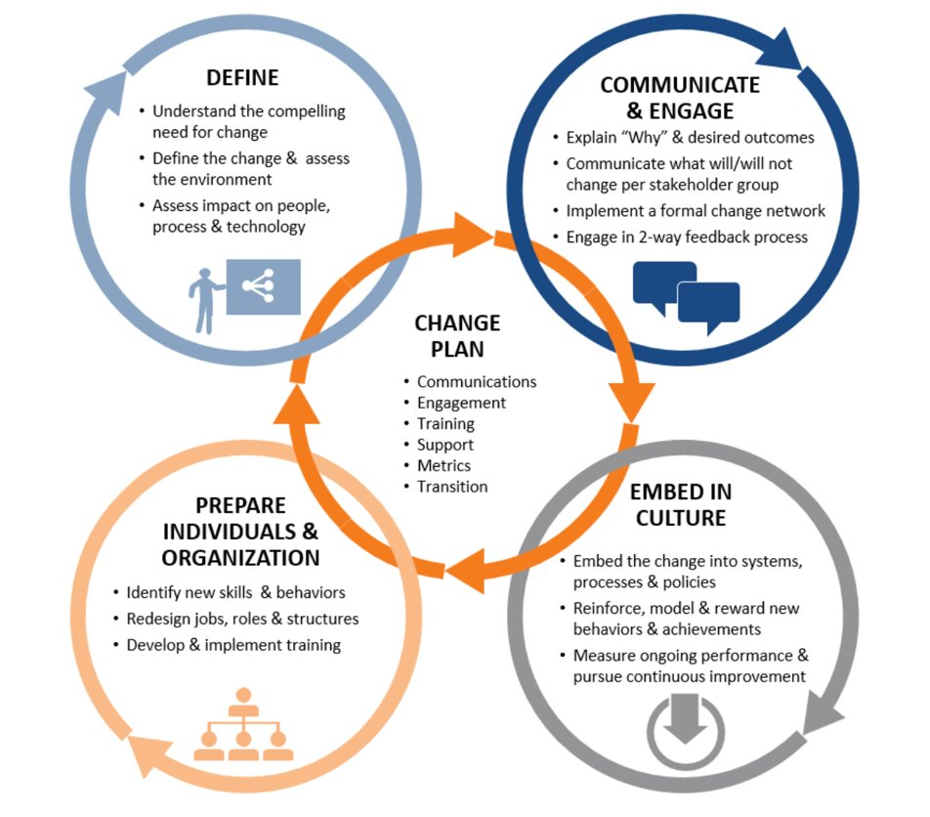

Figure. 10 Change Management (UVA 2019)

## Define

To implement the above-mentioned projects, the ABC Bank needs to have a robust change management plan. From the research conducted by UVA (2019), the change management plan in the figure 10 has been adopted and is well suited for a banking environment. The implementation phase would be brought to life by conducting a project awareness workshop or a presentation for the lead conversion team and defining the compelling need for the change. The team would be educated on the project details, timelines, possible impact, relevant stakeholders, downtime, budget, process and technology (Cameron & Green 2019, p.103).

## Communicate and engage

The second step of the change management is to communicate and engage with the team. The project implementation team must explain the necessity that ABC bank is unable to convert leads and the above-mentioned project may tend to solve the problem. The business requirement will list all the action items, scope of the project, project boundaries, tools required for the project. The project group will also enable a formal email channel where all the updates would be shared to the leads conversion team and will address all concerns of the employees (Cameron & Green 2019, p.65).

## Prepare Individuals and organisation

The change management is responsible for preparing individuals and organisation to adapt to the change. Below are the steps to be followed to achieve the target:

1. Identifying groups or individuals for training in leads management tool, makeshift campaign management and advanced predictive analytics.
2. Enhancing the business capability by re use of existing infrastructure.
3. Redesign jobs and roles based on employee experience, skillset and communication (Cameron & Green 2019, pp.11-137).

## Embed and culture

Lastly the projects could be implemented successfully if the project is embedded as a part of business process change. The project implementation group is responsible for designing of the business process and policies for the ABC bank as a part of change management strategy. Along with the design of the business process the ongoing project must be measured for performance analysis to avoid any deviations and continuous process improvement (Cameron & Green 2019, p.310).

# Conclusion

This Business requirement document will help the project implementation group throughout the project lifecycle to keep the deliverables in line with the business needs. The report initially started off by analysing the relevant stakeholders by plotting them in the influence vs engagement chart. The harm help analysis helped the business analyst to identify potential helpers for the project development. Additionally, user personas were created by business analyst for better understanding of user needs.

Industry analysis was later performed within Australia and outside to gather more information on maximising lead conversion strategy. Once all the business requirements have been gathered and listed in the requirements document, the business analyst focused on the solution analysis where all the possible solutions were taken into consideration. By identifying business capabilities, the three most important business requirements were taken into consideration and the solution was designed to address the problem. A roadmap was designed to implement the solution along with change management strategy, so business as usual activities does not get affected due to change.

# References

Accenture 2003, *The Accenture Customer Contact Transformation Solution: Winning Customer Market Share through Excellence in Sales and Service*, Accenture, viewed 16 August 2019, <https://www.accenture.com/_acnmedia/accenture/conversion-assets/dotcom/documents/local/ja-jp/pdf_1/accenture-consulting-cust-cont-transform.pdf>.

Baden, R., Bender, A., Spring, N., Bhattacharjee, B. and Starin, D., 2009, August. Persona: an online social network with user-defined privacy. In *ACM SIGCOMM Computer Communication Review* (Vol. 39, No. 4, pp. 135-146). ACM.

Bollard, A, Doshi, N & Maxwell M 2014, *The future of US retail-banking distribution*, McKinsey & Company, viewed 15 August 2019,   
<https://www.mckinsey.com/industries/financial-services/our-insights/the-future-of-us-retail-banking-distribution>.

Brown, B & Gottlieb, J 2016, *The need to lead in data and analytics*, McKinsey Digital, 16 April, viewed 2 November 2019, <https://www.mckinsey.com/business-functions/mckinsey-digital/our-insights/the-need-to-lead-in-data-and-analytics>

Cameron, E & Green, M 2019, *Making sense of change management: A complete guide to the models, tools and techniques of organizational change*, Kogan Page Publishers.

Downs, Y & Swailes, S 2013, ‘A capability approach to organizational talent management’, *Human Resource Development International*, vol.*16 no.*3, pp.267-281.

Doyle, S 2005, ‘Business requirements for campaign management—A sample framework’, *Journal of Database Marketing & Customer Strategy Management*, vol. *12, no.* 2, pp.177-192.

Kobler, D, Grampp, M, Hauber, F, Witt, J, Brandes, D, Schlotmann, J & Fischer, N 2015, *Growth in Banking: Unlocking the full potential*, Deloitte, viewed 16 August 2019,  
<https://www2.deloitte.com/content/dam/Deloitte/ch/Documents/financial-services/ch-en-fs-growth-in-banking.pdf>.

Mithas, S, Ramasubbu, N & Sambamurthy, V 2011, ‘How information management capability influences firm performance’, *MIS quarterly*, vol. *35, no.* 1, p.237.

UVA, 2019, 'UVA Change Management Framework', UVA, viewed 25 October 2019, <https://organizationalexcellence.virginia.edu/change-management>.

Weston, A 2016, ‘Are you Agile?’, Infosys, 22 July, viewed 24 October, <https://www.infosysblogs.com/management-consulting/organizational_transformation/>.

Sullivan, B, Garvey, J, Alcocer, J & Eldridge, A 2019, *Retail Banking 2020: Evolution or Revolution?,* PwC, viewed 16 August 2019, <https://www.pwc.com/gx/en/banking-capital-markets/banking-2020/assets/pwc-retail-banking-2020-evolution-or-revolution.pdf>.

Terrizzano, A, Pesaresi, S & Naja, M 2016, *Banking 2016 Accelerating growth and optimizing costs in distribution and marketing, Accenture,* viewed 27 October 2019, <https://www.accenture.com/ae-en/~/media/accenture/conversion-assets/dotcom/documents/global/pdf/industries_3/accenture-banking-2016.pdf>.

Bollard, A, Doshi, N & Maxwell M 2014, The future of US retail-banking distribution, *McKinsey & Company*, viewed 27 October 2019, <https://www.mckinsey.com/industries/financial-services/our-insights/the-future-of-us-retail-banking-distribution>.

Accenture, 2019, *The Top 8 Banking Trends of 2019,* Accenture, pp. 1-5.

Gera, P, Secchi, A, Gagliardi, L, Mcintyre, A & Leruste, C 2018, *Maximizing Revenue Growth in Retail Banking,* Accenture, viewed 26 October 2019, <https://www.accenture.com/_acnmedia/pdf-87/accenture-maximizing-revenue-growth-in-retail-banking.pdf#zoom=50>.

Grant, J 2018, ‘Transforming a Traditional Bank into an Agile Market Leader’, *Strategy+Business,* 19 December, viewed 25 Octobrt 2019, <https://www.strategy-business.com/article/Transforming-a-Traditional-Bank-into-an-Agile-Market-Leader?gko=036bf>.

Groenfeldt, R 2018, ‘Going Digital In Banking – DBS, Citi, BBVA, ING Lead The Way’, *Forbes,* 15 April, viewed 23 October 2019, <https://www.forbes.com/sites/tomgroenfeldt/2018/04/15/going-digital-in-banking-dbs-citi-bbva-ing-lead-the-way/#223af7625877>.

Yeates, C 2019, ‘Meet the ‘neobanks’ trying to shatter the big four banking oligopoly’, *The Sydney Morning Herald,* 17 August, viewed 18 August 2019, <https://www.smh.com.au/business/banking-and-finance/meet-the-neobanks-trying-to-shatter-the-big-four-banking-oligopoly-20190815-p52hiu.html>.